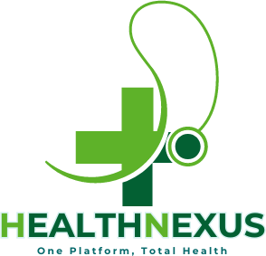

Health Nexus

**Project Report**

**FYP Team: Tech Titans Muhammad Soban 21F-9084 Kashaf Irfan 21F-9154 Khubaib Shabbir 21F-9634**

**Supervisor: Dr. Hafiz Tayyab Javed**



## Department of Computer Science

FAST – National University of Computer & Emerging Sciences

2024 - 2025

**Anti-Plagiarism Declaration**

This is to declare that the above FYP documentation produced under the:

is the sole contribution of the author(s) and no part hereof has been reproduced on **as it is** basis (cut and paste) which can be considered as **Plagiarism.** All referenced parts have been used to argue the idea and have been cited properly. I/We will be responsible and liable for any consequence if violation of this declaration is determined.

**Student 1**

Name: Kashaf Irfan

Signature:

**Student 2**

Name: Khubaib Shabbir

Signature:

**Student 3**

Name: Muhammad Soban

Signature:

**Supervisor (Faculty)** Name: Dr Hafiz Tayyab Javed

Table of Contents

Department of Computer Science

List of Tables: v

List of Figures: vi

1. Introduction 1

2. Literature Review 1

3. Project Vision 1

3.1. Problem Statement 1

3.2. Business Opportunity 1

3.3. Objectives 2

3.4. Project Scope 2

3.5. Constraints 2

3.5.1. Market Demographics 2

3.5.2. Stakeholder Summary 3

3.5.3. User Summary 5

3.5.4. User Environment 6

3.5.5. Stakeholder Profiles 7

3.5.6. User Profiles 9

3.5.7. Alternatives and Competition 10

3.6. Project Overview 11

4. Software Requirements Specification 12

4.1. List of Features 12

4.2. Functional Requirements 12

4.2.1. User Registration and Authentication 12

4.2.2. Patient Case Submission and Management 12

4.2.3. Doctor-Patient Interaction 12

4.2.4. Medication Management and Integration 12

4.2.5. Communication and Notifications 13

4.2.6. Reporting and Analytics 13

4.2.7. Data Security and Privacy 13

4.2.8. Role-Based Access Control 13

4.3. Non-Functional Requirements 13

4.3.1 Performance Requirements: 13

4.3.2 Scalability: 13

4.3.3 Availability and Reliability: 13

4.3.4 Security: 13

5. Product Overview 14

5.1 Product Perspective 14

5.2 Summary and Capabilities 14

5.3 Assumptions and Dependencies 15

5.4 Cost and Pricing 15

5.5 License and Packaging 15

6. Product Features 15

6.1 Medical Case Submission 15

6.2 Appointment Booking 15

6.3 Pharmaceutical Support 15

6.4 Aid Tracking 16

6.5 Medication Reminder 16

6.6 Chatbot Assistance 16

6.7 Case Review and Approval 16

6.8. Loan Tracking 16

7. Restraints 16

8. Quality Ranges 16

9. Precedence & Priority 17

10. Other Product Requirements 17

10.1 Applicable Standards 17

10.2 System Requirements 17

10.3 Performance Requirements 17

11. Documentation Requirements 17

11.1 User Manual 17

11.2 Installation Document 18

12. Feature Attributes 18

12.1 Status 18

12.2. Benefit 18

12.3. Efforts 18

12.4 Stability 18

13. High Level Use Cases 19

14. Iteration 22

14.1 Expanded Use Cases 22

14.2 Activity Diagram 25

14.3.1 Sequence Diagram (Case Submission) 27

14.3.3 Sequence Diagram (Case Review) 28

14.3.5. Sequence Diagram (Medicine Management) 28

14.4 Domain Diagram 30

14.6 Entity-Relation Diagram 32

# List of Tables:

Table 1:Stakeholders Summary 4

Table 2: User Summary 6

Table 3:Stakeholders Profile 8

Table 4:User Profile 10

Table 5:Summary and Capabilities 15

Table 6: Status 19

Table 7:High Level Use Cases 20

Table 8: Expanded Use Cases Tables 23

# List of Figures:

Figure 1-High Level Diagram 11

Figure 2-Use Case Diagram 21

Figure 3-Activity Diagram 25

Figure 4-Sequence Diagram 26

Figure 5 - Sequence Diagram(Case Submission) 27

Figure 6.1-Sequence Diagram(Case Submission) 27

Figure 7-Sequence Diagram (Doctor Appointment) 27

Figure 8-Sequence Diagram (Case Review) 28

Figure 9-Sequence Diagram (Receive Medication Reminder) 28

Figure 10-Sequnce DIagram(Medicine Management) 28

Figure 11-Sequnce Diagram(Chatbot Assistance) 29

Figure 12 - Domain Diagram 30

Figure 13 - Class Diagram 31

Figure 14 - Entity-Relation Diagram 32

# Introduction

Healthcare is a fundamental right, yet in many parts of the world, including Pakistan, access to necessary medical care is sometimes restricted because of financial constraints. People suffering from serious illnesses are obliged to sell their belongings or seek assistance from unofficial sources, which is neither sustainable nor reliable. "Health Nexus" promises to create a platform that connects people with diseases to NGOs, Doctors, and pharmaceutical companies eager to help them pay for their medical expenses. The application will send each patient's case to the on-boarded NGOs for examination to decide how much the patient can afford and how much the NGOs would cover. Pharmaceutical businesses will also participate, offering medications at the lowest feasible prices. Furthermore, the app will manage notifications for patients, reminding them of their prescription schedules and ensuring they take their recommended medicines on time.

# Literature Review

Healthcare assistance platforms have been around for some time, but few offer a comprehensive solution that integrates financial aid from NGOs with affordable medication procurement from pharmaceutical companies. While existing models like Fund healthcare for people around the world, (Watsi, 2024) enables healthcare access worldwide, while (Sehat.Kahani, 2024) focuses on providing healthcare access nationwide and (mPharma, 2013) improves access to medicines.

# Project Vision

This section describes the following.

## Problem Statement

Many people in Pakistan struggle to acquire access to genuine, reasonably priced medications, and this problem gets worse by the high cost of prescribed drugs. Patients are reluctant to use the current healthcare help platforms because they are seen with a great deal of mistrust. The objective is to create an open, reliable platform that offers authentic medications at the most competitive price. "Health Nexus" intends to establish trust by providing credible healthcare solutions and serving as a bridge to connect patients with financial assistance. The "Health Nexus" effort aims to provide a reliable and user-friendly portal that helps consumers get financial assistance for medical care.

## Business Opportunity

Creating software that connects NGOs, pharmaceutical companies, doctors, and patients can open up a variety of financial options:

* One large opportunity exists in the healthcare sector, where this software may help to streamline practice management, increase patient-centric treatment, and manage medical records.
* Another opportunity lies in the pharmaceutical industry, where Health Nexus can help companies to manage their supply chain, track inventory, and optimize logistics.
* Health Nexus can also help NGOs streamline operations, manage donations, and track volunteer activities. They can also gain popularity with the help of this software.
* Doctors can use this software to access patient records, prescribe medications, and schedule appointments, making their workflows more efficient. Patients benefit from having access to their medical records, scheduling appointments, and receiving personalized care.

## Objectives

The primary goal of "Health Nexus" is to create a transparent and efficient platform that bridges the gap between individuals in need of financial assistance for healthcare and the organizations willing to provide that support. The project aims:

* To develop an application that enables patients to request financial assistance for medical expenses.
* To collaborate with reputable NGOs, such as AL-KHIDMAT, to provide interest-free loans to patients.
* To partner with pharmaceutical companies to procure medications at the lowest possible rates.
* To ensure a transparent and efficient process for evaluating and approving financial assistance requests.
* To facilitate a system where patients can receive financial assistance and, once recovered, contribute back.
* Enhance the revenue streams for stakeholders, including NGOs and pharmaceutical companies, by creating a reliable and large-scale platform

## Project Scope

Health Nexus is a complete application meant to allow financial assistance for healthcare in Pakistan by connecting patients in need with organizations eager to help. The project aims to create a user- friendly platform where patients can enter their health information and financial needs, which will be processed and forwarded to partnered NGOs for evaluation. These non-governmental organizations (NGOs) will verify the cases and evaluate the level of financial support required. Furthermore, pharmaceutical companies will be incorporated into the system to provide pharmaceuticals at the lowest feasible cost, ensuring that patients obtain vital treatments without incurring unnecessary financial hardship. The software will also contain a notification system to remind patients of expected prescription needs, allowing them to stick to their recommended treatments. Health Nexus ensures that no one is denied essential medical care due to financial constraints.

## Constraints

Following section describes the constraints for our projects related to problem statements.

### Market Demographics

With a primary focus on Pakistan, the software will serve both urban and semi-urban areas, with the possibility of expanding into rural areas with poor access to healthcare. Patients from low- to middle- class backgrounds who have difficulty affording healthcare, NGOs with mission-driven objectives to assist those in need, pharmaceutical companies looking to expand their market share and engage in corporate social responsibility, and doctors looking for effective patient management tools are the main users. Due to rising awareness, adoption of new technologies, and growing healthcare demands, Pakistan's healthcare business is expanding quickly, which makes the country a perfect fit for a platform of this kind. This software can play a vital role as CSR (Corporate Social Responsibility) and digital health adoption pick up steam, improving access to healthcare and assistance for people in need.

### Stakeholder Summary

*Table 1:Stakeholders Summary*

|  |  |  |
| --- | --- | --- |
| **Name** | **Description** | **Responsibilities** |
| **FAST-NU** | This stakeholder has all  the rights for the Health Nexus. | The stakeholder is responsible for rights and the permission for development. |
| **Development Team** | This stakeholder is responsible for  designing and developing this product. The stakeholder will be analyzing the development and management of the product at certain levels as well. | The stakeholder has the accountability for meeting development timelines and for effectively documenting the product.  It is the stakeholder's responsibility to keep an accurate record of the entire product.  Stakeholders will have exclusive control on design schemes, diagrams, and architectures, as well as over production code. |
| **NGOs** | Reputable-non-governmental organizations(NGOs) collaborating to provide financial assistance to patients. | Evaluate patient cases, provide funds for medical treatments, and ensure transparency in fund disbursement. Collaborate  with pharmaceutical companies and doctors. |
| **Pharmaceutical Companies** | Companies that partner with Health Nexus to offer medications at the lowest possible cost. | Provide authentic medications, manage inventory, and ensure compliance with regulatory standards.  Participate in medication  bidding processes and fulfill orders. |

|  |  |  |
| --- | --- | --- |
| **Supervisor** | The stakeholders in this section includes a Supervisor and he is serving as a project manager to make the team work. | This stakeholder is in charge of supervising the development teams and the necessary development.  Prior to the deadlines, he served as a filter, and he will serve as the project lead through completion. He will also be documenting the project's advancement. |

### User Summary

*Table 2: User Summary*

|  |  |  |  |
| --- | --- | --- | --- |
| **Name** | **Description** | **Responsibilities** | **Stakeholder** |
| **Patient** | Individuals in need of financial support for medical treatment. These users seek assistance from NGOs and pharmaceutical companies through the Health Nexus app. | Register on the platform, submit medical cases, book doctor appointments, communicate with NGOs, and track their case progress. | Self |
| **Doctor** | Medical professionals who evaluate patient cases, verify diagnoses, and provide treatment recommendations through the Health Nexus platform. | Review cases, issue prescriptions, offer medical consultations, and collaborate with NGOs and pharmaceutical companies for patient care. | Self |
| **NGO Staff** | Personnel from NGOs responsible for reviewing submitted patient cases and deciding on financial aid allocation. | Evaluate patient cases, approve financial aid, and collaborate with doctors and pharmaceutical companies. | NGOs |
| **Pharmaceutical Companies Representative** | Representatives from pharmaceutical companies who manage the medication supply and process orders for patients at the lowest possible rates. | Offer medications, participate in bidding, and ensure timely delivery of required medications. | Pharmaceutical Companies |

### User Environment

The **"Health Nexus"** application is a web-based platform, accessible via any device with a web browser and an active internet connection. Patients and other users can access the platform from their desktops, laptops, tablets, or smartphones. The platform will be optimized for mobile use but will not require any specific mobile operating system installation, as it operates directly through a web interface.

### Stakeholder Profiles

*Table 3:Stakeholders Profile*

|  |  |  |  |  |  |  |  |
| --- | --- | --- | --- | --- | --- | --- | --- |
| **StakeHolder** | **Description** | **Type** | **Responsibil ities** | **Success Criteria** | **Involvemen t** | **Deliverabl e** | **Comments**  **/issues** |
| **Development Team** | Responsib le for the design, developm ent, and managem ent of the "Health Nexus" platform, including implemen tation and feature integratio  n. | Develo pment Team | Ensure efficient product development  , coding, testing, and deployment. | Deliver the web applicati on on time with full function ality and proper docume ntation. | Developme nt, testing, deployment  , and support. | Completed product features and system requiremen ts. | None |
| **NGOs** | Non- governme ntal organizati ons responsibl e for providing financial aid to patients through the Health Nexus  platform. | Financ ial Stakeh older | Evaluate patient cases and disburse financial aid directly to healthcare providers or pharmaceuti cal companies. | Success is defined by the number of patients receivin g aid and the transpar ency of the process. | Case review, fund disburseme nt, and reporting. | Timely fund disburseme nts and impact reports. | Need for streamlined communica tion with other stakeholder s. |
| **Pharmaceutic al Companies** | Pharmace utical partners providing medicatio n at the lowest possible rates to patients in  need. | Medic ation Provid er | Manage drug inventory, participate in the bidding process, and fulfill orders for approved medications. | Success depends on the timely and affordab le provisio n of  medicati ons. | Bidding, order fulfillment, compliance  . | Medication delivery and order fulfillment reports. | Potential need for more partners to meet demand. |

|  |  |  |  |  |  |  |  |
| --- | --- | --- | --- | --- | --- | --- | --- |
| **Supervisor** | Project supervisor s overseein g the Health Nexus developm ent, ensuring timely delivery and that developm  ent goals are met. | Project Manag er &  Expert | Ensure that the development process runs smoothly, overseeing team performance  , and addressing issues promptly. | Success is determin ed by  on-time delivery of features and overall project completi on. | Project managemen t and oversight. | All project milestones completed on time. | None |

### User Profiles

*Table 4:User Profile*

|  |  |  |  |  |  |  |  |
| --- | --- | --- | --- | --- | --- | --- | --- |
| **User** | **Descrip tion** | **Type** | **Responsibil ities** | **Success Criteria** | **Involvement** | **Deliverabl e** | **Comments/ Issues** |
| **Patient** | Individu als seeking financia l assistan ce for medical care through  Health Nexus. | End User | Register on the platform, submit medical cases, communicat e with doctors, and track their  case progress. | Ease of use in submitting cases, booking appointme nts, and accessing medication  . | Full involvement in using the platform for aid and healthcare access. | Medical case submission s, notification s, and appointmen t booking. | None |
| **Doctor** | Medical professi onals responsi ble for reviewi ng cases, issuing prescrip tions, and providin g consulta  tions. | Medic al Staff | Review patient cases, provide medical advice, issue prescription s, and offer follow-up care. | Success is defined by timely medical consultatio ns, accurate diagnoses, and seamless interaction with patients. | Active involvement in case review, consultations, and collaboration with NGOs and pharmaceutic al companies. | Prescriptio ns and medical reports. | Need for clear communicati on tools for patient interactions. |
| **NGO**  **Staff** | NGO  employe es responsi ble for reviewi ng patient cases and determi ning  financia l aid. | Finan cial Stake holder | Evaluate patient cases, approve or deny financial aid, and communicat e with patients and pharmaceuti cal companies. | Timely and transparent financial aid approvals and fund disbursem ents. | Involvement in the evaluation of cases and coordination with healthcare providers. | Financial aid approvals and disburseme nt reports. | Collaboratio n challenges with multiple NGOs. |

### Alternatives and Competition

There are various alternatives and competitive solutions for health funding platforms and pharmaceutical aid globally:

#### Sehat Kahani

An online healthcare platform offering telemedicine services to low-income populations. Sehat Kahani connects patients with doctors through its mobile app for consultations. However, it lacks a feature for directly connecting patients with financial assistance or pharmaceutical companies**.**

#### Watsi

Watsi is a healthcare platform that isn't very accessible in Pakistan and doesn't concentrate on establishing connections with local pharmacies or NGOs. But Watsi distinguishes itself by giving patients direct financial support, assisting with donations to cover their medical costs. The platform focusses more on raising money for patient care than on creating vast local healthcare networks. It does not deal directly with doctors or offer interest-free loans.

#### mPharma

mPharma is an expert in establishing connections with pharmacies and providing solutions to guarantee the supply of reasonably priced drugs. Its reach is restricted to pharmaceutical ties, though, as it does not function in Pakistan and does not have direct interaction with NGOs or medical professionals. It does not provide interest-free loans or financial aid; instead, it concentrates on the pharmaceutical supply chain, not on patient financing or more comprehensive healthcare support.

## Project Overview

The following section will list basic product overview that will include High Level Diagram.

* + 1. ***High Level Diagram***

Figure -High Level Diagram 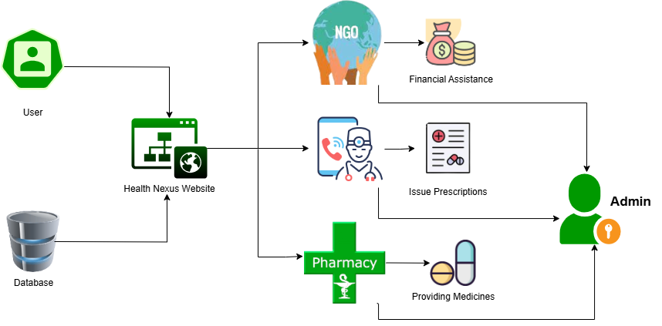

# Software Requirements Specification

The Software Requirements Specification (SRS) for Health Nexus is covered in this section. It will provide an explanation of the application that needs to be produced in accordance with the SRS document requirements in the software industry.

## List of Features

The software includes the following features for the user:

* Medical Case Submission
* Appointment Booking
* Pharmaceutical Support
* Aid Tracking
* Medication Reminder
* Chatbot Assistance
* Case Review and Approval
* Donation Tracking

## Functional Requirements

Following functional requirements corresponding to the features are discussed here.

### User Registration and Authentication

* The ability to sign up and log in securely using an email address, phone number, or social media profiles is a requirement for users (patients, physicians, NGOs, and pharmaceutical corporations).
* For improved security, use multi-factor authentication (MFA).

### Patient Case Submission and Management

* For assessment, patients must be able to provide their financial needs, medical records, and health information.
* NGOs should be able to manage, review, and confirm patient cases through the system.

### Doctor-Patient Interaction

* Doctors need to be able to directly prescribe drugs on the platform and access patient details.
* Permit medical professionals to arrange and supervise patient appointments.

### Medication Management and Integration

* Pharmaceutical companies need to be able to manage inventory, determine prices, and display available medications.
* The system need to make it easier for individuals to receive prescription drugs at the most affordable price.

### Communication and Notifications

* Make secure texting possible for NGOs, physicians, and patients.
* Patients should receive automated reminders for their medications, appointment times, and case status updates.

### Reporting and Analytics

* Reports on case reviews, aid provided, and effect analyses should be given to NGOs.
* Pharma companies must have access to information about the impact of CSR and the distribution of medications.

### Data Security and Privacy

* To protect sensitive information, put in place strong access controls, data encryption, and compliance with data protection laws.

### Role-Based Access Control

* To make sure that every kind of user can only access the data and functionalities that are pertinent to their position

## Non-Functional Requirements

### Performance Requirements:

* + - * The system should load the main dashboard within 3 seconds for all user roles.
      * The app should handle at least 1,000 concurrent users without performance degradation.

### Scalability:

* The platform must be scalable to accommodate future growth in users, data, and features.
* The system architecture should support horizontal scaling to add more servers as needed without significant modifications.

### Availability and Reliability:

* The system should have 99.9% uptime, ensuring that the platform is available at all times, except during scheduled maintenance.
* Implement failover mechanisms and redundancy to prevent downtime in case of server failures.

### Security:

* All data transmissions must be encrypted using SSL/TLS protocols.
* User data, especially sensitive health and financial information, must be stored securely with encryption at rest.

# Product Overview

This section describes the overall functionality and vision of the "Health Nexus" web platform.

## Product Perspective

The **"Health Nexus"** platform is a standalone web application. It leverages external APIs for secure communication between patients, NGOs, doctors, and pharmaceutical companies. The base design focuses on transparency, security, and accessibility, ensuring that patients can trust the platform for medical aid and healthcare appointments. The chatbot feature enhances user experience by providing instant answers to common queries.

## Summary and Capabilities

*Table 5:Summary and Capabilities*

|  |  |
| --- | --- |
| **Customer Benefit** | **Supporting Features** |
| Medical Aid Request | Patients can submit medical cases for evaluation by NGOs, ensuring financial support and transparency. |
| Pharmaceutical Support | Patients can receive medications from partnered pharmaceutical companies at reduced rates. |
| Case Tracking | Patients can track their aid request from submission to approval, maintaining transparency throughout. |
| Medication Reminder | Notifications remind patients to take their medication on time, helping ensure adherence to treatment plans. |
| Book Appointments | Patients can contact doctors directly and book appointments for consultations through the web platform. |
| Chatbot Assistance | The integrated chatbot provides immediate responses to common inquiries, improving user experience and offering guidance. |

## Assumptions and Dependencies

Key assumptions and dependencies include:

* A stable internet connection is required for both patients and NGOs to interact effectively.
* Partnered NGOs must have systems in place for reviewing and approving patient cases.
* Pharmaceutical companies must ensure availability of the medications listed on the platform.
* Doctors must provide timely availability for booking appointments.
* Patients should provide accurate medical and financial information for accurate assessments.
* The chatbot functionality will be available to handle common queries and guide users through the process.

## Cost and Pricing

The **"Health Nexus"** platform is free to use for patients. The final cost of medications or treatment depends on the portion covered by NGOs or discounts provided by pharmaceutical companies. Patients can access the platform from any device with an internet connection.

## License and Packaging

The **"Health Nexus"** platform will be accessible as a web-based application. The application ensures secure data handling with encryption for all transactions and interactions. It will be available through a designated domain, with all users—patients, doctors, NGOs, and pharmaceutical companies— registering to interact securely.

# Product Features

The product features for the **"Health Nexus**" web platform are as follows:

## Medical Case Submission

Patients can securely submit their medical cases, including diagnosis details, required treatment, and cost estimates. The platform forwards these cases to onboarded NGOs for evaluation and financial assistance.

## Appointment Booking

The platform allows patients to contact doctors and book appointments directly. This feature provides patients with easy access to medical consultations, ensuring timely care without financial or logistical barriers.

## Pharmaceutical Support

Patients can receive medications from partnered pharmaceutical companies at the lowest possible cost. The system facilitates secure transactions between pharmaceutical companies and patients to ensure the timely delivery of required medications.

## Aid Tracking

Patients can track the progress of their medical aid requests, from submission to final approval. This feature ensures transparency by keeping patients informed about the status of their applications.

## Medication Reminder

The platform includes a notification system that reminds patients of their prescribed medication schedules. This ensures adherence to treatment plans and helps patients manage their health more effectively.

## Chatbot Assistance

The integrated chatbot provides instant assistance to users by answering common queries related to their health cases, appointments, and platform navigation. This feature helps streamline the user experience and reduces the need for manual support.

## Case Review and Approval

NGOs can review the medical cases submitted by patients and decide on the level of financial aid required. This feature ensures that every case is evaluated efficiently, and patients receive the assistance they need.

## 6.8. Loan Tracking

Manage and track loan received through the platform.

# Restraints

* A stable internet connection is required for both patients and NGOs to submit and review medical cases, book appointments, and access other platform features.
* Partner NGOs, doctors, and pharmaceutical companies must be available to process cases and provide the necessary support on time.
* Pharmaceutical companies must ensure the availability of required medications to avoid delays in treatment.
* The platform must adhere to strict data security and privacy standards, ensuring all communications and transactions are encrypted.
* Chatbot functionality relies on accurate and up-to-date responses to common user inquiries.

# Quality Ranges

The Health Nexus web platform will provide an intuitive, user-friendly interface. Patients can seamlessly interact with the website to access necessary medical aid. The system will optimize the process of connecting patients with NGOs and pharmaceutical companies, ensuring ease of use and high operational efficiency through a responsive and easily accessible web platform.

# Precedence & Priority

* Priority for Financial Aid Request Submission is high.
* Priority for Medication Procurement is high.
* Priority for NGO Evaluation is high.
* Priority for Patient Notification and Adherence Tracking is medium.
* Priority for Data Privacy and Security is high.
* Priority for Admin and Case Monitoring is medium.

# Other Product Requirements

The **Health Nexus** web platform is designed with the following compatibility requirements:

## Applicable Standards

The **Health Nexus** platform is entirely web-based and accessible across major browsers such as Chrome, Firefox, and Microsoft Edge, regardless of the user's operating system (Windows, macOS, Linux, etc.). The platform requires a stable internet connection for optimal performance, and the platform’s functionality may be reduced if the internet connection is weak or disrupted.

## System Requirements

* A computer, laptop, tablet, or mobile device with internet access and a modern web browser to access the web interface.
* A reliable internet connection is necessary to minimize delays and ensure smooth operation of real-time processes like case submissions and communication with NGOs and pharmaceutical companies.

## Performance Requirements

* The platform should function seamlessly on any device (PC, laptop, tablet, or mobile) that can access the web through supported browsers.
* Stable and fast internet connectivity is required to avoid delays in submitting financial aid requests, processing transactions, and communicating with patients and NGOs

# Documentation Requirements

This section outlines the necessary documentation to ensure the successful deployment and operation of the **Health Nexus** web-based platform.

## User Manual

A user manual will be provided as part of the web platform’s "Help" section. Users will be able to refer to it for guidance on how to navigate the site, submit medical cases, and interact with NGOs and pharmaceutical companies through the platform.

## Installation Document

As a web-based platform, there is no need for installation. The platform will be accessible through all major browsers (Chrome, Firefox, Microsoft Edge), and users will be able to access it directly via a URL, without any software downloads required.

# Feature Attributes

This section outlines the key attributes of the **Health Nexus** web platform, providing details on its status, benefits, required effort, and expected stability.

## 12.1 Status

The following table summarizes the status of the web platform’s development:

*Table 6: Status*

|  |  |
| --- | --- |
| Status | Description |
| Proposed | The purpose of the **Health Nexus** web platform is to allow users to submit their medical cases and connect with NGOs and pharmaceutical companies for financial and medical aid through a streamlined online interface. |
| Approved | The development of the web-based Health Nexus platform has been approved. The platform will enable users to access healthcare-related financial assistance and medications through NGO and pharmaceutical collaborations, all through a secure web  interface. |

## Benefit

The primary benefit of the **Health Nexus** platform is to provide users with an easy-to-access web portal for requesting financial aid and discounted medications. The platform will act as a bridge between patients and relevant NGOs, enabling them to apply for assistance and access affordable medical supplies from pharmaceutical partners—all from a single, centralized web portal.

## Efforts

The effort required to develop the Health Nexus platform includes designing an intuitive web interface, ensuring security for user data, and integrating with NGO and pharmaceutical company databases. Details on development stages and required work efforts are outlined in the project work plan. Ensuring smooth interaction and minimal latency during case submissions and data exchanges will be a key focus.

## 12.4 Stability

The project scope remains stable as of now, with no significant changes or modifications suggested by faculty or the supervisor. Since the platform is web-based, any future updates or adjustments can be rolled out efficiently without requiring users to download updates or make manual changes.

# High Level Use Cases

The following section describes high-level use cases that will be implemented in Health Naxus.

*Table 7:High Level Use Cases*

|  |  |  |  |  |
| --- | --- | --- | --- | --- |
| No. | Use Case Name | Actor | Type | Description |
| **1** | Register | Patient, Admin | Primary | Patients and admins register by providing personal details to create accounts. |
| **2** | Case Submission | Patient | Primary | Patients submit their medical case details to request financial aid and support. |
| **3** | Assign Medical Cases | Admin | Primary | Admin assigns submitted cases to NGOs or relevant doctors for review and processing. |
| **4** | Manage Appointments | Admin, Doctor | Primary | Admins and doctors manage and update patient appointments. |
| **5** | Get Appointments | Patient, Doctor | Primary | Patients book appointments, and doctors confirm and schedule them. |
| **6** | Issue Prescriptions | Doctor | Primary | Doctors prescribe medication for patients based on their case details. |
| **7** | Reviewing Case | NGO | Primary | NGOs review patient cases to determine eligibility for financial assistance. |
| **8** | Giving Loan | NGO | Primary | NGOs provide interest-free loans or financial aid to eligible patients. |
| **9** | Disburse Financial Aid | NGO | Primary | NGOs release financial support directly to patients or healthcare providers. |
| **10** | Submit Medication Gigs | Pharmaceutical Companies | Primary | Pharmaceutical companies list medications and offer bids for affordable drugs. |
| **11** | Fulfill Medication Orders | Pharmaceutical Companies | Primary | Pharmaceutical companies process and deliver ordered medications to patients. |

|  |  |  |  |  |
| --- | --- | --- | --- | --- |
| **12** | Track Medication Records | Patient | Primary | Patients view and monitor their medication records using the platform. |
| **13** | Receive Medication Reminders | Patient | Primary | Patients receive reminders about their prescribed medication schedules. |
| **14** | Chatbot Assistance | Patient, Admin | Primary | Patients and admins interact with the chatbot for guidance and support. |
| **15** | Maintain Data Security | Admin | Primary | Admin ensures sensitive data is encrypted and securely maintained. |
| **16** | Manage Accounts | Admin | Primary | Admins manage user, doctor, and NGO accounts on the platform. |
| **17** | Manage Chatbot | Admin | Primary | Admins monitor and maintain the chatbot's functionality. |
| **18** | Selecting Affordable Gig | Admin | Primary | Admins select pharmaceutical companies offering affordable medications. |

**13.1 Use Case Diagram**

Figure -Use Case Diagram

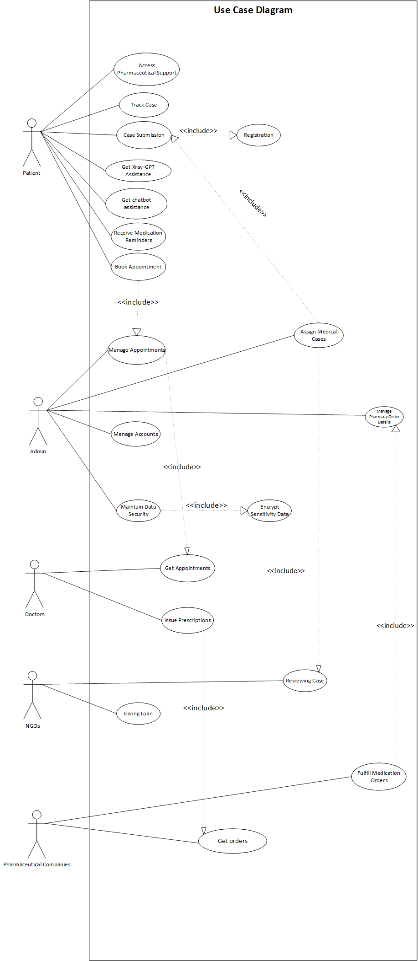

# Iteration

The section defines steps for first iteration of Health Nexus.

## Expanded Use Cases

*Table 8: Expanded Use Cases Tables*

#### Use Case 1: Case Submission

|  |  |  |
| --- | --- | --- |
| No. | Section | Content |
| **1.** | Use case name | Case Submission |
| **2.** | Authors | Kashaf Irfan |
| **3.** | Priority | High |
| **4.** | Source | Health Nexus Project |
| **5.** | Description | The patient submits their medical case for review. |
| **6.** | Trigger Event | Patient clicks the "Submit Case" button. |
| **7.** | Actors | Patient |
| **8.** | Pre-conditions | 1. Patient is registered. 2. Relevant details ready. |
| **9.** | Post-conditions | 1. Case is saved in the system. 2. Forwarded to NGOs. |
| **10.** | Main Scenario | 1. Patient logs in. 2. Navigate to “Submit Case”. 3. Fill in Details. 4. System Confirms Submission |
| **11.** | Alternative Scenario | 2a. System prompts if any required information is missing. |

**Use Case 2: Get Appointments**

|  |  |  |
| --- | --- | --- |
| **No.** | **Section** | **Content** |
| **1.** | Use case name | Get Appointments |
| **2.** | Authors | Kashaf Irfan |
| **3.** | Priority | Medium |
| **4.** | Source | Health Nexus Project |
| **5.** | Description | Patient books an appointment with a doctor. |
| **6.** | Trigger Event | Patient clicks "Book Appointment" button. |
| **7.** | Actors | Patient, Doctor |
| **8.** | Pre-conditions | 1. Patient is registered. 2. Doctors available. |

|  |  |  |
| --- | --- | --- |
| **9.** | Post-conditions | 1. Appointment scheduled. 2. Notifications sent |
| **10.** | Main Scenario | 1. Patient selects a doctor. 2. Choose a time slot. 3. System confirms and send notification. |
| **11.** | Alternative Scenario | 2a. If no slots are available, system suggests alternatives. |

#### Use Case 3: Receive Medication Reminders

|  |  |  |
| --- | --- | --- |
| No. | Section | Content |
| **1.** | Use case name | Receive Medication Reminders |
| **2.** | Authors | Khubaib Shabbir |
| **3.** | Priority | Medium |
| **4.** | Source | Health Nexus Project |
| **5.** | Description | Patients receive reminders for their medication schedules. |
| **6.** | Trigger Event | Reminder notification is due. |
| **7.** | Actors | Patient |
| **8.** | Pre-conditions | 1. Active prescription exists. 2. Notifications enabled. |
| **9.** | Post-conditions | 1. Reminder sent to the patient. |
| **10.** | Main Scenario | 1. System checks for due reminders. 2. Sends notification. |
| **11.** | Alternative Scenario | 2a. If reminder not acknowledged, a follow-up is sent. |

**Use Case 4: Case Review**

|  |  |  |
| --- | --- | --- |
| **No.** | **Section** | **Content** |
| **1.** | Use case name | Case Review |
| **2.** | Authors | Muhammad Soban |
| **3.** | Priority | High |
| **4.** | Source | Health Nexus Project |
| **5.** | Description | NGOs review cases and approve financial aid. |
| **6.** | Trigger Event | Case assigned to an NGO. |
| **7.** | Actors | NGOs, Admin |
| **8.** | Pre-conditions | 1. Case submitted by patient. 2. NGO registered on platform. |
| **9.** | Post-conditions | 1. Aid approved. 2. Funds transferred to provider. |
| **10.** | Main Scenario | 1. Admin assigns the case. 2. NGO reviews and approves |

|  |  |  |
| --- | --- | --- |
|  |  |  |
| **11.** | Alternative Scenario | 2a. If NGO can’t support, it forwards the case. |

#### Use Case 5: Manage Medication Orders

|  |  |  |
| --- | --- | --- |
| No. | Section | Content |
| **1.** | Use case name | Manage Medication Orders |
| **2.** | Authors | Muhammad Soban |
| **3.** | Priority | Medium |
| **4.** | Source | Health Nexus Project |
| **5.** | Description | Pharmaceutical companies handle medication orders. |
| **6.** | Trigger Event | Order request is generated. |
| **7.** | Actors | Pharmaceutical Companies |
| **8.** | Pre-conditions | 1. Company registered. 2. Medications in stock. |
| **9.** | Post-conditions | 1. Order processed. 2. Dispatched to provider/patient. |
| **10.** | Main Scenario | 1. Company receives order. 2. Verifies availability. 3. Dispatches order. |
| **11.** | Alternative Scenario | 2a. If out of stock, suggests alternatives. |

**Use Case 6: Manage Chatbot Assistance**

|  |  |  |
| --- | --- | --- |
| No. | Section | Content |
| **1.** | Use case name | Manage Chatbot Assistance |
| **2.** | Authors | Khubaib Shabbir |
| **3.** | Priority | Low |
| **4.** | Source | Health Nexus Project |
| **5.** | Description | Chatbot provides assistance for general queries. |
| **6.** | Trigger Event | Patient initiates chat. |
| **7.** | Actors | Patient, Admin |
| **8.** | Pre-conditions | 1. Chatbot system active. 2. Patient logged in. |
| **9.** | Post-conditions | 1. Query resolved or escalated. |
| **10.** | Main Scenario | 1. Patient opens chatbot. 2. Asks a question. 3. Chatbot provides relevant info. |
| **11.** | Alternative Scenario | 3a. If chatbot can’t respond, escalates to human operator. |

## Activity Diagram

Figure -Activity Diagram

* 1. **Sequence Diagram**

Figure -Sequence Diagram

### Sequence Diagram (Case Submission)

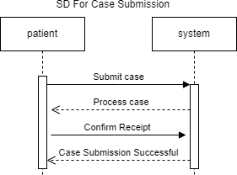

Figure - Sequence Diagram(Case Submission)

Figure .1-Sequence Diagram(Case Submission)

* + 1. ***Sequence Diagram (Doctor Appointment)***

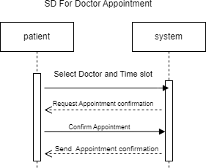

Figure -Sequence Diagram (Doctor Appointment)

### Sequence Diagram (Case Review)

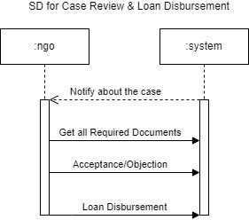

Figure -Sequence Diagram (Case Review)

* + 1. ***Sequence Diagram (Receive Medication Reminder)***

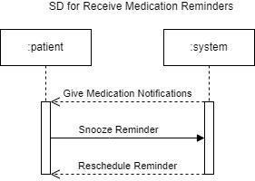

Figure -Sequence Diagram (Receive Medication Reminder)

### Sequence Diagram (Medicine Management)

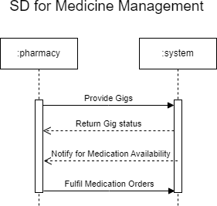

Figure -Sequnce DIagram(Medicine Management)

* + 1. ***Sequence Diagram (Chatbot Assistance)***

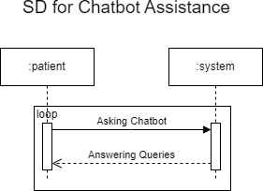

Figure -Sequnce Diagram(Chatbot Assistance)

## Domain Diagram

Figure - Domain Diagram

* 1. **Class Diagram**

Figure - Class Diagram

## Entity-Relation Diagram

Figure - Entity-Relation Diagram

